Repetition Datenbanken

# Aufgabe 1

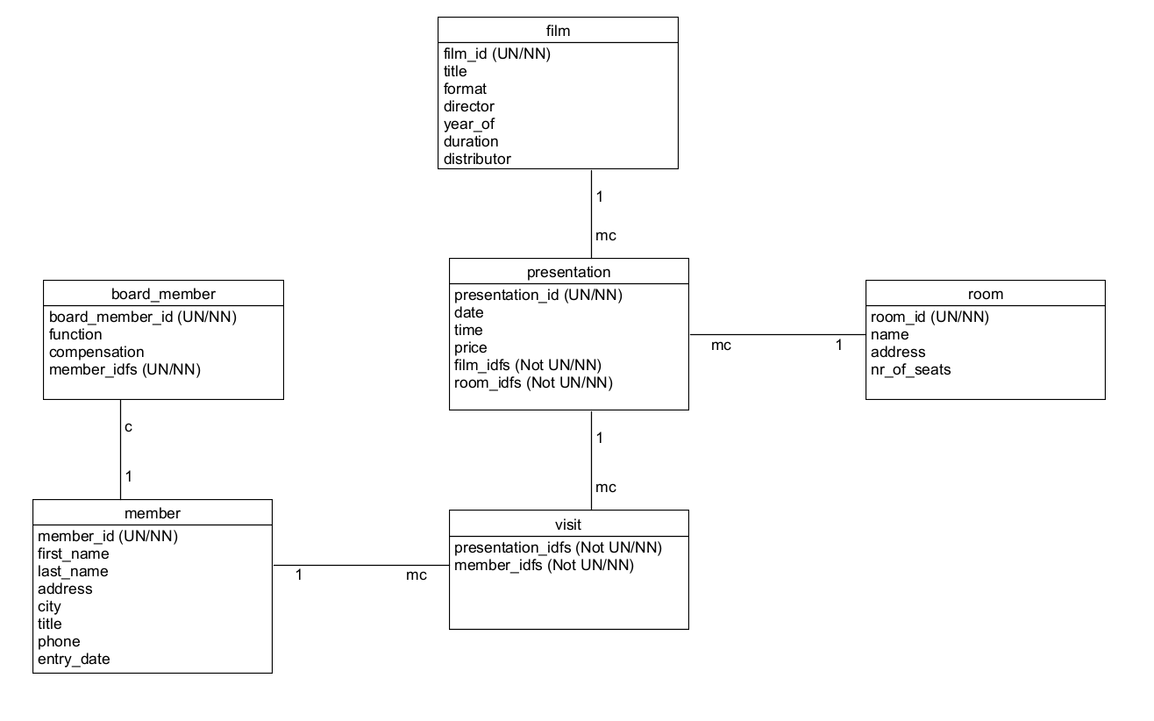

# Aufgabe 2

SELECT first_name, last_name FROM member

WHERE last_name LIKE 'm%'

ORDER BY last_name, first_name ASC;

1. Nachname: Mack

Letzter Nachname: Mutter

# Aufgabe 3

SELECT film.title AS "Titel", presentation.date AS "Aufführungsdatum" FROM film

JOIN presentation ON film.film_id = presentation.presentation_id

WHERE presentation.date LIKE '2018-%'

ORDER BY presentation.date, film.title ASC;

1. Titel: FACULTY, THE / USA

Letzter Titel: TAPEZ 36-15 CODE CORBA / CH/BRD

# Aufgabe 4

SELECT film.* FROM film

LEFT (OUTER) JOIN presentation ON film.film_id = presentation.film_idfs

WHERE presentation.presentation_id IS NULL

ORDER BY film.title;

1.Titel: A NIGHT AT THE OPERA / USA

Letzter Titel: TITANIC

# Aufgabe 5

SELECT film.title, COUNT(presentation.presentation_id) FROM presentation

RIGHT JOIN film ON film.film_id = presentation.film_idfs

GROUP BY film.film_id

ORDER BY COUNT(presentation.presentation_id), film.title

1.Titel: A NIGHT AT THE OPERA/ USA

Letzter Titel: THE PERFECT STORM / USA

# Aufgabe 6

SELECT film.*, COUNT(member.member_id) AS "Anzahl Mitglieder" FROM film

JOIN presentation ON film.film_id = presentation.film_idfs

JOIN visit ON visit.presentation_idfs = presentation.presentation_id

JOIN member ON member.member_id = visit.member_idfs

GROUP BY film.film_id

ORDER BY COUNT(member.member_id) DESC, film.title ASC;

1.Titel & Anz. Besucher: NOTTING HILL/ GB | 460

Letzter Titel & Anz. Besucher: PETER'S FRIENDS | 14

# Aufgabe 7

SELECT member.*, COUNT(visit.presentation_idfs) AS "Anzahl besuchte Präsentationen" FROM board_member

JOIN member ON board_member.member_idfs = member.member_id

JOIN visit ON visit.member_idfs = member.member_id

GROUP BY board_member.board_member_id

ORDER BY COUNT(visit.presentation_idfs)

LIMIT 1;

Name / Vorname des Vorstandmitglieds: Fucht / Walter